Department of Revenue Services
State of Connecticut
Taxpayer Services Division
25 Sigourney Street
Hartford CT 06106-5032

(Rev. 01/05)

CERT-122

Refund of Tax Paid on Purchases of Meals or Lodging by Exempt Entities

General Purpose: Exempt organizations, qualifying governmental agencies, nonprofit charitable hospitals, nonprofit nursing homes, nonprofit rest homes,
and nonprofit residential care homes must use this certificate to request a refund of tax paid on a qualifying exempt purchase of meals or lodging. (Any
reference to tax in this document includes sales and use taxes and room
occupancy tax, as applicable.) These organizations, governmental agencies, hospitals, and homes will be referred to as exempt entities throughout this
certificate. Use this certificate only if all four of these conditions are met:
1. The retailer directly invoices and charges the exempt entity for the meals
or lodging; and
2. The exempt entity directly pays the retailer with a check drawn on its own
account or with a credit card issued in its own name; and
3. The exempt entity is not reimbursed, in whole or in part, by donation or
otherwise, for its payment for the meals or lodging by those consuming the
meals or lodging; and
4. This certificate is filed with the Department of Revenue Services (DRS)
within three years from the last day of the month after the period for
which the sales tax was paid.
Statutory Authority: Conn. Gen. Stat. §12-412(1)(A), (5), (8), and (94);
§12-425.
Credit Card Purchases: If a credit card is used to pay the retailer of meals
or lodging, the card must be issued in the name of the exempt entity. The
credit card must be used exclusively to make purchases for the use of the
exempt entity (not for the convenience of its officers, employees, or members). The credit card charges must be paid by a check drawn on the exempt entity's
own checking account.
Nonqualifying Purchases: This certificate may not be used (and tax will
not be refunded) on the purchase of meals or lodging not meeting all four conditions above. Nonqualifying purchases include fundraisers where those
who attend are charged or are required to make any payment and seminars or
conferences where meals or lodging are included in the conference or seminar registration fee except as described below.
An exempt entity may purchase meals tax exempt using CERT-113, Purchases
of Tangible Personal Property and Services by a Nonprofit Charitable Hospital,
Nonprofit Nursing Home, Nonprofit Rest Home, or Nonprofit Residential Care
Home; CERT-119, Purchases of Tangible Personal Property and Services by Qualifying Exempt Organizations; or CERT-134, Exempt Purchases by
Qualifying Governmental Agencies; when it will resell the meals at one of five
fundraising or social events per year that is exempt from tax under Conn. Gen. Stat. §12-412(94) including meals resold at conferences and seminars. If a
qualifying exempt entity pays tax on meals and later resells them at these
events, the organization may request a refund from DRS without using CERT-122. See Special Notice 98(11), Exemption From Sales and Use Taxes
of Sales by Nonprofit Organizations at Fundraising or Social Events,
Informational Publication 2002(11), Nonprofit Hospitals, Nonprofit Nursing Homes, Nonprofit Rest Homes, and Nonprofit Residential Care Homesand
Policy Statement 98(5), Sales and Use Tax Refund Policy.
Government Purchases Not Requiring Preapproval: The federal
government has implemented the "GSA SmartPay" program, which uses four categories of credit cards: Fleet, Purchase, Travel, and Integrated cards. Federal
employees may purchase meals and lodging tax exempt by using certain GSA
SmartPay credit cards when the purchases are billed to and paid by the federal government. U.S. government agencies making tax-exempt purchases of meals
and lodging using GSA SmartPay cards are not required to get preapproval for
these purchases from DRS and are not required to provide the retailer with CERT-112, Exempt Purchases of Meals or Lodging by Exempt Entities. See
Policy Statement 2000(1.1), Retailer's Acceptance of U.S. Government "GSA
SmartPay" Credit Card for Exempt Purchases.

Who Should File This Certificate: If the exempt entity did not receive prior approval of exemption from DRS, either because it was reimbursed in whole or in
part, for certain meals or lodging (although not reimbursed in whole or in part for
other meals or lodging) or because it did not submit a properly completed CERT- 112 at least three weeks before the event, the exempt entity must pay the tax to
the retailer at the time of the purchase of the meals or lodging. It may then
request a refund of tax paid on the particular meals or lodging for which it was not reimbursed, in whole or in part, by submitting this certificate to DRS.
Events That Qualify for Refund Only: If the exempt entity will be paying
(and will not be reimbursed, in whole or in part) for the meals or lodging of some of the attendees, but will be reimbursed in whole or in part for the meals or
lodging of others, a preapproved exemption will not be issued. The exempt
entity must pay tax on all the meals or lodging at the time of purchase. However, if the exempt entity files CERT-122, and DRS approves the certificate, DRS will
refund the tax on those meals or lodging paid by the exempt entity and not
reimbursed in whole or in part. The exempt entity is not eligible for a refund of the tax paid on meals or lodging for which it received full or partial reimbursement
other than for meals sold under the five one-day fundraising events per calendar
year exemption. See Policy Statement 2003(4), Purchases of Meals or Lodging by Exempt Entities, for more information.
Example 1: B, an exempt organization, sponsors a dinner to honor one of its
members. The restaurant charges B $50 per meal and B sells tickets for $50 per person. The honoree and members of the immediate family attend as
guests of the organization. B must pay sales tax on all meals purchased. It
may, however, complete and file CERT-122 to claim a refund of the taxes paid only on meals consumed by the honoree and members of the immediate family.
Example 2: C, an exempt organization, sponsors a retirement dinner to honor
one of its employees. The restaurant charges C $60 per meal. C sells tickets for $50 per person and pays the $10 difference to the restaurant from its own
funds. C must pay sales tax on the full price of all meals purchased. Because
the organization received partial reimbursement for all of the meals, C is not eligible for a refund of any of the tax paid.
Instructions for the Purchaser: An officer of an exempt entity must
complete and sign this certificate to request a refund of taxes paid on the
qualifying exempt purchase of meals or lodging. If the purchaser is an exempt organization, it must attach either a copy of its I.R.C. §501(c)(3) or (13)
determination letter issued by the U.S. Treasury Department or, if it was issued
an exemption permit by DRS, enter its exemption permit number on CERT-122. If the purchaser is a qualifying governmental agency, no attachment
is required. If the purchaser is a nonprofit charitable hospital, nonprofit nursing
home, nonprofit rest home, or nonprofit residential care home, it must attach a copy of a valid and active license issued by the Department of Public Health
under Chapter 368v of the Connecticut General Statutes and either a copy of its
I.R.C. §501(c)(3) or (4) determination letter issued by the U.S. Treasury Department or, if it was issued an exemption permit by DRS, enter its exemption
permit number on CERT-122. If DRS concludes a qualifying exempt purchase
was made, the tax paid will be refunded to the purchaser. Keep a copy of this certificate and records that substantiate the information entered on this
certificate for at least six years from the date it was issued. The following
items must be included with CERT-122:
1. A copy of an itemized bill directly invoicing and charging the exempt
entity for the meals or lodging. The bill must separately state the amount
of sales tax charged on meals and lodging; and either
2. A copy of the cancelled check(s) (front and back), including the initial
deposit, drawn on the exempt entity's checking account, directly paying
for the meals or lodging; or
3. If payment is made by credit card, a copy of the exempt entity's credit card
statement showing the purchase of the meals and lodging and a copy of the cancelled check(s) (front and back) drawn on the exempt entity's checking
account that paid the credit card bill.

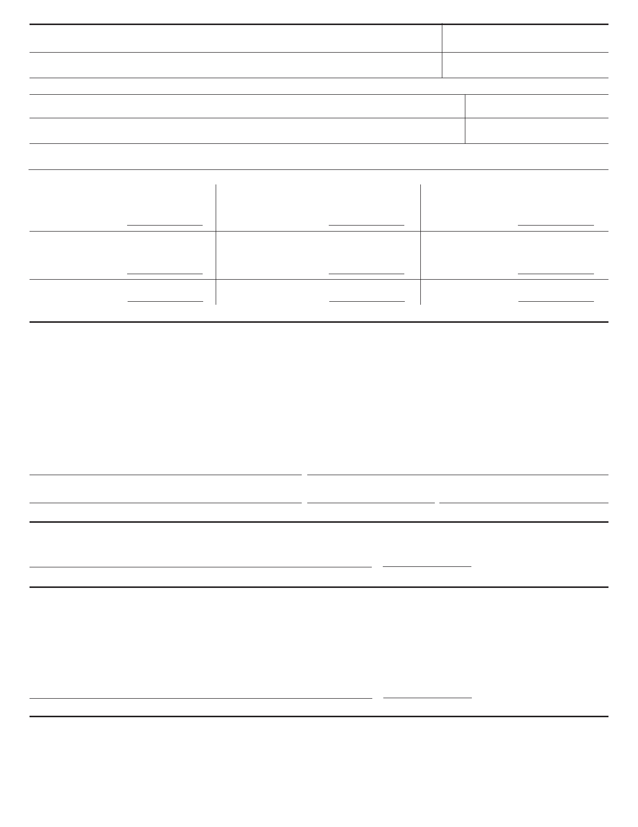Name of Exempt Entity: Federal Employer Identification Number
06-1234567
Your Public School District Here

Address of Exempt Entity Connecticut Exemption Permit Number (If any)
0123456789
Your Address Here

(If the exempt entity was not issued a Connecticut exemption permit (E-number), attach a copy of the exempt entity's I.R.C. §501(c)(3), (4), or (13) determination letter.)

Name of Retailer Check Appropriate Box(es)
Retailer Here
Meals Lodging
Address of Retailer Date(s) of Event
Date(s) Here
Address Here

Describe Purpose or Reason for Event: (Be specific. For example, meeting of board of trustees, or luncheon to honor volunteers)
Description Here

The exempt entity must provide the following information about the purchases of meals or lodging: (See instructions)

Column A
Total Number of Meals or Lodging Purchased

0.00

Total Cost of Meals or Lodging Purchased
(Excluding Tax)
0.00
$

Total Tax Paid

Column B
Number for Which No Reimbursement, Full or
Partial, Was Received
0.00

Cost of Meals or Lodging for Which No
Reimbursement, Full or Partial, Was Received
(Excluding Tax)
0.00
$

Total Tax Paid
0.00
Column C
Number for Which Reimbursement, Full or
Partial, Was Received
0.00

Cost of Meals or Lodging for Which
Reimbursement, Full or Partial, Was Received
(Excluding Tax)
0.00
$

Total Tax Paid
0.00

on This Amount $ on This Amount $ on This Amount $
The sum of the numbers entered in Column B and in Column C should equal the number entered in Column A.

Declaration by Exempt Entity
I declare that the exempt organization, qualifying governmental agency, nonprofit charitable hospital, nonprofit nursing home, nonprofit rest home, or nonprofit
residential care home:
• Was directly invoiced and charged by the retailer;
• Directly paid the retailer with a check drawn on its own account or with a credit card issued in its own name; and
• Was not or will not be reimbursed, directly or indirectly, by donation or otherwise, for all or a portion of the cost of the meals or lodging by those consuming
the meals or lodging.
I also declare that any exemption permit noted on this certificate, any determination letter or group exemption letter (as the case may be), and license issued
by the Department of Public Health, if applicable, attached to this certificate, has not been canceled or revoked. I declare under penalty of law that I have
examined this document (including any accompanying schedules and statements) and, to the best of my knowledge and belief, it is true, complete, and correct.
I understand the penalty for willfully delivering a false return or document to DRS is a fine of not more than $5,000, or imprisonment for not more than five
years, or both. The declaration of a paid preparer other than the taxpayer is based on all information of which the preparer has any knowledge.

Print Name
Business Manager or Designee

Authorized signature

Request Approved by DRS

Official Approval/DRS

Request Disapproved by DRS

Title
Title

Date

This Section is Completed by DRS

Date Approved

860-555-5555
Telephone Number

Exempt entity did not provide proof of exempt status. (Connecticut exemption permit number or I.R.C. §501(c)(3), (4), or (13) determination letter and
the license issued by the Department of Public Health, if applicable.)
Exempt entity was not directly invoiced and charged by the retailer of the meals or lodging.
Exempt entity did not directly pay the retailer of the meals or lodging with a check drawn on its own checking account or with a credit card issued in its own name (and not in the name of one of its members, employees, or officers).
Exempt entity was or will be reimbursed, in whole or in part, for its payment for the meals or lodging by those consuming the meals or lodging.
Certificate was not timely filed.

Official Disapproval/DRS Date Disapproved

For More Information: For other information, call the Exempt Organization Coordinator at 1-800-382-9463 (in-state) and choose Option 0 or 860-297-5962 (from anywhere). TTY, TDD, and Text Telephone users only may transmit inquiries anytime by calling 860-297-4911. Preview and download forms and
publications from the DRS Web site at www.ct.gov/DRS
Submit this certificate for approval to: Department of Revenue Services
Taxpayer Services Division - Exempt Organization Coordinator
25 Sigourney Street
CERT-122 (Rev. 01/05) Hartford CT 06106-5032

