
Department of Revenue Services
State of Connecticut
Taxpayer Services Division
25 Sigourney Street
Hartford CT 06106-5032

(Rev. 01/05)

CERT-123

Blanket Certificate for Exempt Qualifying Purchases of Meals or Lodging
by an Exempt Organization or Qualifying Governmental Agency

General Purpose: Exempt organizations or qualifying governmental
agencies should use this certificate to establish that their purchases of meals
or lodging are exempt from sales and use taxes. This certificate may be used
only if these four conditions are met:
1. The retailer directly invoices and charges the exempt organization or
qualifying governmental agency for the meals or lodging;
2. The exempt organization or qualifying governmental agency directly pays
the retailer with a check drawn on its own account or with a credit card
issued in its own name;
3. The exempt organization or qualifying governmental agency is not
reimbursed, in whole or in part, by donation or otherwise, for its payment
for the meals or lodging by those consuming the meals or lodging; and
4. The purchase of the meals or lodging occurs before the expiration date
specified on the blanket certificate.
Statutory Authority: Conn. Gen. Stat. §12-412(1)(A), (8) and (94).
Credit Card Purchases: If a credit card is used to pay the retailer of meals
or lodging, the card must be issued in the name of the exempt organization or
qualifying governmental agency. The credit card must be used exclusively to make purchases for the use of the exempt organization or qualifying
governmental agency (not for the convenience of its officers, employees or
members). The credit card charges must be paid by a check drawn on the
organization's or agency's own checking account.
Nonqualifying Purchases: This certificate may not be used (and tax must
be paid) on the purchase of meals or lodging not meeting all four of the
conditions above. Nonqualifying purchases include fund raisers where those
who attend are charged or are required to make any payment and seminars or conferences where meals or lodging are provided at no extra charge to those
paying the conference or seminar registration fee.
However, a qualifying exempt organization may purchase meals exempt from
tax using CERT-119, Purchases of Tangible Personal Property and Services
by Qualifying Exempt Organizations, or CERT-134, Exempt Purchases by
Qualifying Governmental Agencies, and does not have to get prior approval from the Department of Revenue Services (DRS), when the organization will
resell the meals at one of five fundraising or social events per year that is
exempt from tax under Conn. Gen. Stat. §12-412(94). See Special Notice 98(11), Exemption From Sales and Use Taxes of Sales by Nonprofit
Organizations at Fundraising or Social Events.
Purchases Not Requiring Preapproval: The federal government recently
implemented the "GSA SmartPay" program, which uses four categories of
credit cards: Fleet, Purchase, Travel, and Integrated cards. Federal employees
may purchase meals and lodging tax exempt by using certain GSA SmartPay cards when the purchases are billed to and paid by the federal government.
U.S. government agencies making tax-exempt purchases of meals and lodging
using GSA SmartPay cards are not required to get preapproval for these purchases from DRS and are not required to provide the retailer with
CERT-112, Exempt Purchases of Meals or Lodging by Exempt Entities. See
Policy Statement 2000(1.1), Retailer's Acceptance of U.S. Government "GSA SmartPay" Credit Card for Exempt Purchases.
Instructions for the Purchaser: An officer of an exempt organization or
qualifying governmental agency must complete and sign this certificate and submit it to DRS for qualifying exempt purchases of meals or lodging during
a one year period. If the purchaser is an exempt organization, it must attach
either a copy of its I.R.C. §501(c)(3) or (13) determination letter issued by the U.S. Treasury Department or, if it was issued an exemption permit by
DRS, enter its exemption permit number on CERT-123. If the purchaser is a
qualifying governmental agency, no attachment is required. If DRS concludes
that qualifying exempt purchases are being made, the certificate, with DRS
official approval noted, will be returned to the exempt organization or qualifying governmental agency. The exempt organization or qualifying governmental
agency must then provide the approved CERT-123 to the retailer of meals or
lodging. Keep a copy of this certificate, documents attached, and records that substantiate the information on this certificate for at least six years from the
date it is issued.
Events That Qualify for Refund Only: If the exempt organization or
qualifying governmental agency will be paying (and will not be reimbursed, in
whole or in part) for the meals or lodging of some of the attendees but will be
reimbursed in whole or in part for the meals or lodging of others, a preapproved exemption will not be issued. The exempt organization or qualifying
governmental agency must pay tax on all the meals or lodging at the time of
the purchase. However, DRS will refund the tax on those meals or lodging that were paid for by the exempt organization or qualifying governmental
agency for which it was not reimbursed. The exempt organization or qualifying
governmental agency must file, and DRS must approve, CERT-122, Refund of Sales Tax Paid on Purchases of Meals or Lodging by Exempt Entities. The
exempt organization or qualifying governmental agency is not eligible for
refund of tax paid on those meals or lodging for which it received full or partial reimbursement. See Policy Statement 2003(4), Purchases of Meals or
Lodging by Exempt Entities, for additional information.
Example 1: B, an exempt organization, sponsors a dinner at a restaurant to
honor one of its members. The restaurant charges B $50 per meal and B sells
tickets for $50 per person. The honoree and members of the immediate
family attend as guests of the exempt organization. B must pay sales tax on all meals purchased. It may, however, complete and file CERT-122 to claim
a refund of the taxes paid only on meals consumed by the honoree and
members of the immediate family.
Example 2: C, an exempt organization, sponsors a retirement dinner at a
restaurant to honor one of its employees. The restaurant charges C $60 per
meal. C sells tickets for $50 per person and pays the $10 difference to the restaurant from its own funds. C must pay sales tax on the full price of all
meals purchased. Because the organization received partial reimbursement
for all of the meals, C is not eligible for a refund of any of the tax paid.
Instructions for Retailer of Meals or Lodging: Accept this certificate
only if you directly invoice and charge the exempt organization or qualifying
governmental agency for the meals or lodging. Accept the certificate only if you are directly paid by the exempt organization or qualifying governmental
agency with a check drawn on the exempt organization's or qualifying
governmental agency's own checking account or with a credit card issued in the organization's or agency's name (not in the name of one of its members,
employees or officers). Cash payments will not satisfy this condition,
regardless of the cost of the meals or lodging.
Acceptance of this certificate, when properly completed and with DRS official
approval noted, relieves the retailer from the burden of proving the sale of
meals or lodging is not subject to sales and use taxes. This certificate is valid only if taken in good faith from an exempt organization or qualifying
governmental agency.
Keep a copy of this certificate, the attached documents, and bills or invoices
to the purchaser for at least six years from the date the meals or lodging were
purchased. The bills, invoices or records covering the purchase made under
this certificate must be marked "Exempt Under CERT-123" to indicate an exempt purchase has occurred.

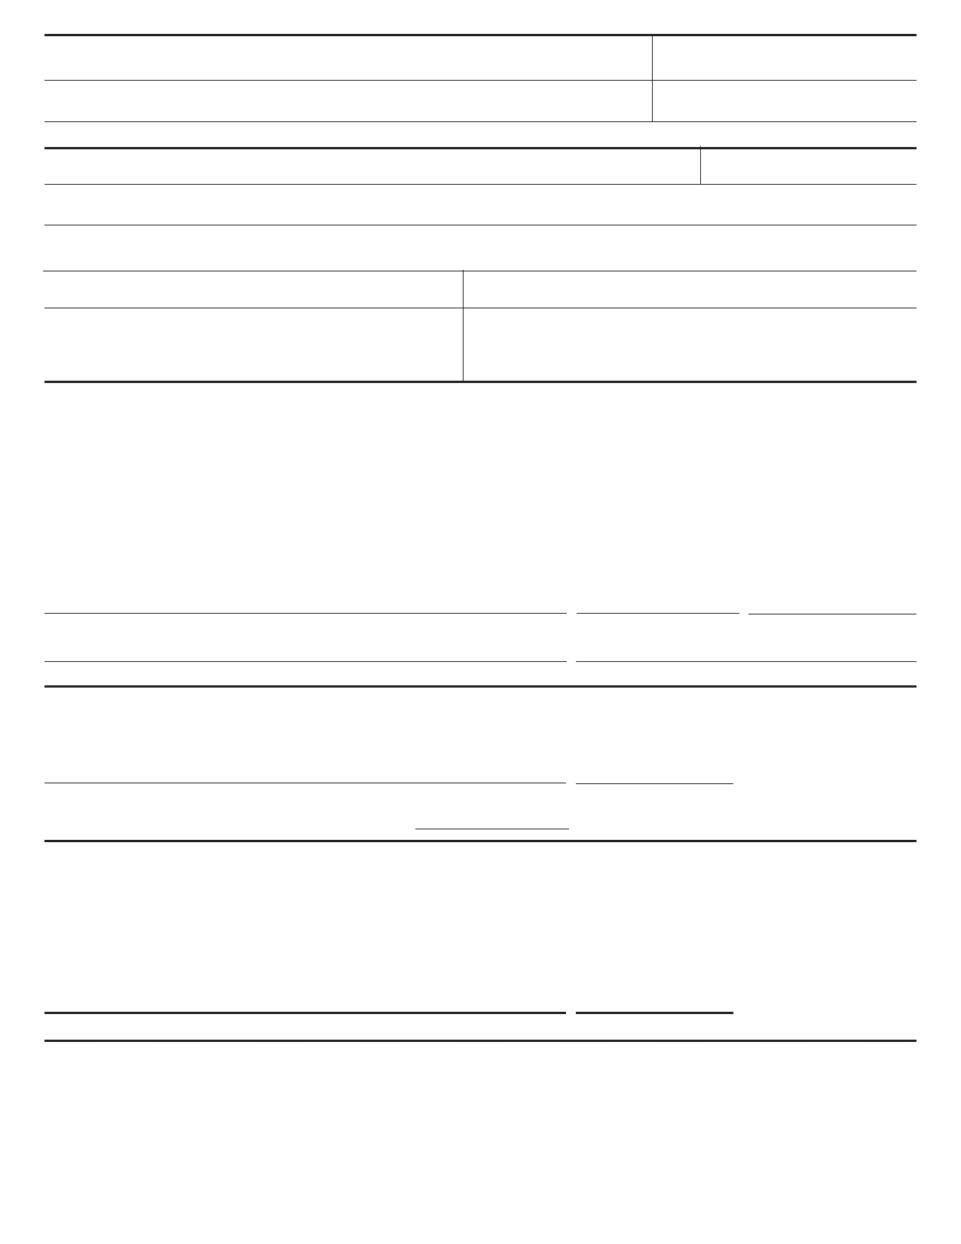
Name of: (Check one box) Exempt Organization X Qualifying Governmental Agency Federal Employer Identification Number
06-1234567
School District

Address of Exempt Organization or Qualifying Governmental Agency Connecticut Exemption Permit Number (If any)
Address
1234567

(If the exempt organization was not issued a Connecticut exemption permit (E-number), attach a copy of the exempt organization's I.R.C. §501(c)(3) or (13) determination letter.)

Name of Retailer Check Appropriate Box(es)
Name
Meals Lodging
Address of Retailer
Address

Describe Purpose or Reason for Events: (Be specific. For example, meeting of board of trustees, or luncheon to honor volunteers)
Reason

Will the exempt organization or qualifying agency receive reimbursement, Will the retailer of the meals or lodging directly invoice and charge the agency
full or partial, for any or all of the meals or lodging? Yes No or organization for the meals or lodging? Yes No

Will a charge, by whatever name called, be made for the meals or lodging Will the agency or organization directly pay the retailer of the meals or lodging
by the exempt organization or qualifying governmental agency to those with a check drawn on its own checking account or with a credit card issued in its who will consume the meals or lodging? own name (and not in the name of one of its members, employees or officers)?
Yes No Yes No

Declaration by Exempt Organization or Qualifying Governmental Agency
I declare that the exempt organization or qualifying governmental agency:
• Is being directly invoiced and charged by the retailer;
• Is directly paying the retailer with a check drawn on its own account or with a credit card issued in its own name; and
• Will not be reimbursed, directly or indirectly, by donation or otherwise, for all or a portion of the cost of the meals or lodging by those consuming the
meals or lodging.
I also declare that any exemption permit noted on this certificate or any determination letter or group exemption letter (as the case may be) attached to this
certificate has not been canceled or revoked. I declare under penalty of law that I have examined this document (including any accompanying schedules and statements) and, to the best of my knowledge and belief, it is true, complete, and correct. I understand the penalty for willfully delivering a false return or document to DRS is a fine of not more than $5,000, or imprisonment for not more than five years, or both. The declaration of a paid preparer other than the taxpayer is based on all information of which the preparer has any knowledge.

Signature of Authorized Person Date Telephone Number
Name of Business Mgr or Designee
Title

Print or Type Name Print or Type Title

Notice to Retailers: Do not accept this certificate if the following section has not been completed and DRS official approval has not been noted.
This Section is Completed by the Department of Revenue Services
Request Approved by the Department

Official Approval/Department of Revenue Services Date Approved

Expiration of Blanket Certificate: This certificate expires on

Request Disapproved by the Department
Exempt organization did not provide proof of exempt status. (Connecticut exemption permit number or I.R.C. §501(c)(3) or (13) determination letter.)
Exempt organization or qualifying governmental agency will not be directly invoiced and charged by the retailer of the meals or lodging.
Exempt organization or qualifying governmental agency will not directly pay the retailer of the meals or lodging with a check drawn on its own checking
account or with a credit card issued in its own name (and not in the name of one of its members, employees or officers).
Exempt organization or qualifying governmental agency will be reimbursed, in whole or in part, for its payment for the meals or lodging by those
consuming the meals or lodging.

Official Disapproval/Department of Revenue Services Date Disapproved

For More Information: For other information, call the Exempt Organization Coordinator at 1-800-382-9463 (in-state) and choose Option 0 or 860-297-5962 (from anywhere). TTY, TDD, and Text Telephone users only may transmit inquiries anytime by calling 860-297-4911. Preview and
download forms and publications from the DRS web site at www.ct.gov/DRS
Submit this certificate for approval to: Department of Revenue Services
Taxpayer Services Division
Exempt Organization Coordinator
25 Sigourney Street
CERT-123 (Back) Hartford CT 06106-5032
(Rev. 01/05)

